Year 10 Debating Team Success
After winning the Zone 5 Premier’s Debating Challenge, the Year 10 Reds Debating team became the South-West Sydney Regional Champions defeating Elderslie High School. On Wednesday, 11th September, Hurlstone debated against Smiths Hill in the State Quarter Finals. As winners of this debate, they will now debate against Caringbah High on the 15th October in the State Semi-Final.
The team work well together and are to be congratulated on their success.
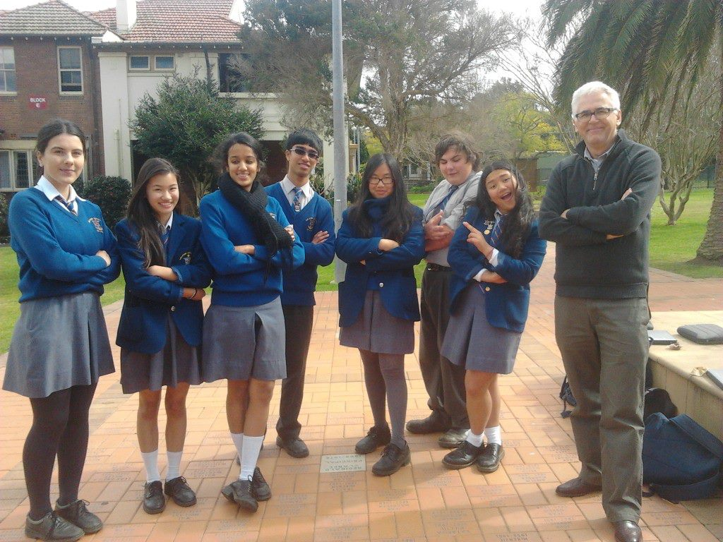
(Left to right)
Anamarija Mrkela, Felicia Tran, Sowmya Padki, Vincent Anthony, Mary Nguyen , Scott Essam, Krisha Umali and Lloyd Cameron(State Debating Coordinator)
Mrs Jodie Hatton
Year 10 Debating Coordinator

